**Ideation Phase**

**Define the Problem Statements**

|  |  |
| --- | --- |
| Date | 27 June 2025 |
| Team ID | LTVIP2025TMID59438 |
| Project Name | ShopSmart: Your Digital Grocery Store Experience |
| Maximum Marks | 2 Marks |

**Customer Problem Statement Template:**

Create a problem statement to understand your customer's point of view. The Customer Problem Statement template helps you focus on what matters to create experiences people will love.

A well-articulated customer problem statement allows you and your team to find the ideal solution for the challenges your customers face. Throughout the process, you’ll also be able to empathize with your customers, which helps you better understand how they perceive your product or service.

**Example:**

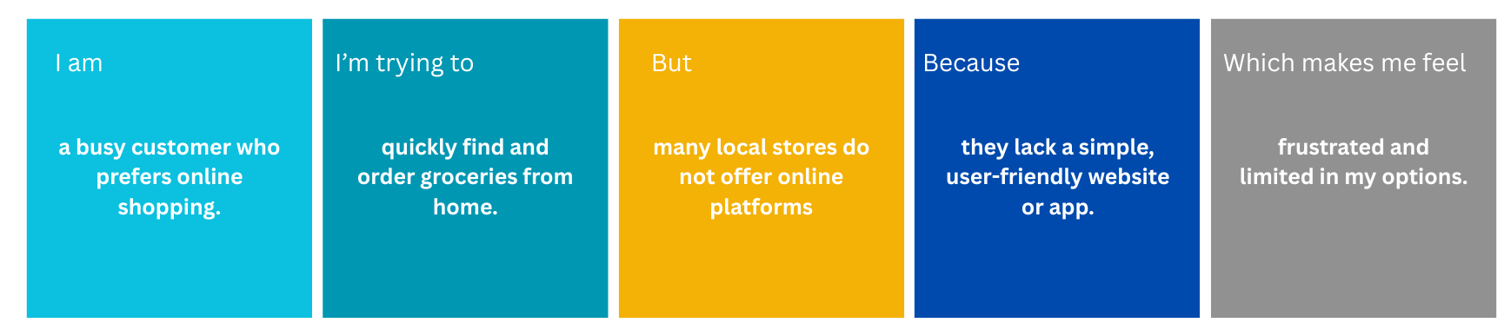

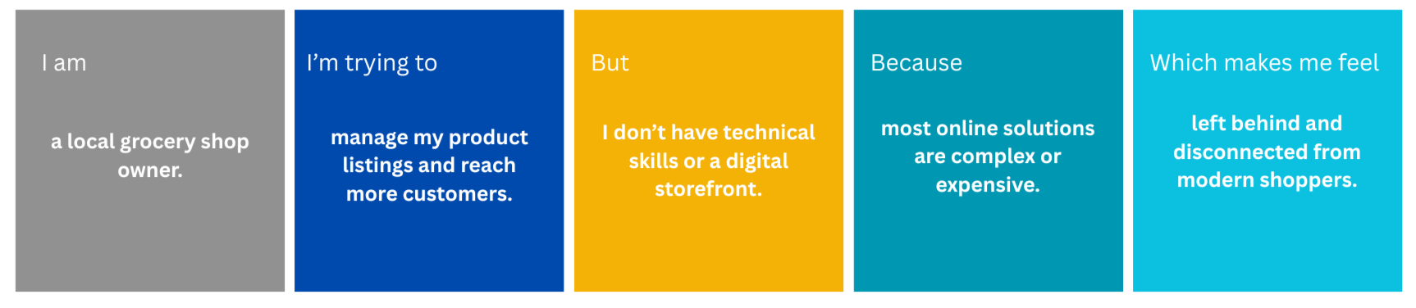

|  |  |  |  |  |  |
| --- | --- | --- | --- | --- | --- |
| **Problem Statement (PS)** | **I am (Customer)** | **I’m trying to** | **But** | **Because** | **Which makes me feel** |
| PS-1 | a busy customer who prefers online shopping. | quickly find and order groceries from home. | many local stores do not offer online platforms | they lack a simple, user-friendly website or app. | frustrated and limited in my options. |
| PS-2 | a local grocery shop owner. | manage my product listings and reach more customers. | I don’t have technical skills or a digital storefront. | most online solutions are complex or expensive. | left behind and disconnected from modern shoppers. |